

Operation Manual – TubeSystem & Business Central Integration

Project Name – MITME
Document Name – Operation User Manual - MITME v3.0
Prepared by: Square International Technology Consulting DMCC.

Submitted By:

Submitted To:


Contents
Summary 4
Document History 4
Change Record 4
Document Review 4
Distribution List 4
Customer Staging 5
Fields 5
Action 5
Item Staging 6
Fields 6
Action 6
Location Staging 7
Fields 7
Action 7
Purchase Order Staging 8
Fields 8
Action 9
Purchase Receipt Staging 9
Fields 9
Action 9
Sales Order Staging 10
Fields 10
Action 10
Sales Shipment Staging 11
Fields 11
Action 11
Transfer Order Staging 11
Fields 12
Action 12
Mill Master Staging 13
Fields 13
Action 13
Production Issue Receipt Stagging 14
Fields 14
Action 14
Inventory Adjustment Staging 15
Fields 15
Action 16
Vendor Staging 17
Fields 17
Action 17
Sales Invoice Staging 17
Fields 17
Action 18
Sales Return Order Staging 18
Fields 18
Action 18

Summary
The purpose of this document is to provide comprehensive guidance and instructions to users on how to effectively utilize a Tube System Integration with Business Central. This document serve as a vital resource for users, offering detailed information on Operational Steps, troubleshooting, and any other relevant aspects of using the Tube System Integration with Business Central.

Document History

Change Record
Date | Author | Version | Revision Notes
26/Jan/2024 | Mr. Abdulla | v1.0 | First Draft
29/Jan/2024 | Mr. Abdulla | v2.0 | Second Draft

Document Review
Name | Position | Version Approved | Date
Mr. Pushparaj Parthasarathi | Lead Functional Consultant | V2.0 | 30/Jan/2024

Distribution List
Name | Company
Mr. Usman Raza | MITME

Customer Staging

Fields
- Entry No. : This field will automatically display number, but we can also assign manually.
- No. : This field represent customer no. If we get two or more records with same no. from tube stream then the last record which we or job queue insert in customer will overwrite previous ones. This field is required to insert in ‘Customer Master’.
- Entry Date and Time : This field will automatically display date and time when record is inserted in this staging table.
- Integration Status : This field specifies whether a record is inserted or not or if there is error while inserting. So, the status ‘Pending’ represents record is not inserted, ‘Processed’ represents record is inserted/updated and ‘Error’ represents record couldn’t inserted.
- Error Remarks : It will tell what the error is.

Action
- Insert/Update Customer: We can manually insert in ‘Customer’ in Business Central with this action. When we click on this action it checks for required fields like here field ‘No.’ Then if there is no error it will insert it in Customer and a message will pop up in image below.
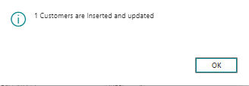
And ‘Integration Status’ will change to ‘Processed’. 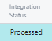
But if there is an error then it will change to ‘Error’ and ‘Error Remarks’ will tell what the error is. For example –
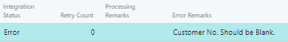
With this action we can manually insert in ‘Customer’, but system will automatically insert with job queue. Job queue will run every day and it will check if there is any record with ‘Pending’ Status. If there is then job queue will insert and update it.

Item Staging

Fields
- Entry No. : This field will automatically display number, but we can also assign manually.
- TS Item No. : This field represent item no. If we get two or more records with same no. from tube stream then the last record which we or job queue insert in Item will overwrite previous ones. This field is required to insert in ‘Item Master’.
- Basic Unit of Measure : Specifies the base unit used to measure the item. This field is required.
- Entry Date and Time : This field will automatically display date and time when record is inserted in this staging table.
- Integration Status : This field specifies whether a record is inserted or not or if there is error while inserting. So, the status ‘Pending’ represents record is not inserted, ‘Processed’ represents record is inserted/updated and ‘Error’ represents record couldn’t inserted.
- Error Remarks : It will tell what the error is.

Action
- Insert/Update Customer : We can manually insert in ‘Item’ in Business Central with this action. When we click on this action it check for required fields like here field ‘TS Item No.’ and ‘Basic Unit of Measure’. Then if there is no error it will insert it in Item and a message will pop up in image below.
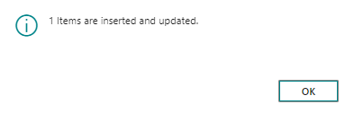
And ‘Integration Status’ will change to ‘Processed’. 
But if there is an error then it will change to ‘Error’ and ‘Error Remarks’ will tell what the error is. For example –
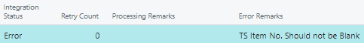
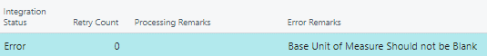
With this action we can manually insert in ‘Item’, but system will automatically insert with job queue. Job queue will run every day and it will check if there is any record with ‘Pending’ Status. If there is then job queue will insert and update it.

Location Staging
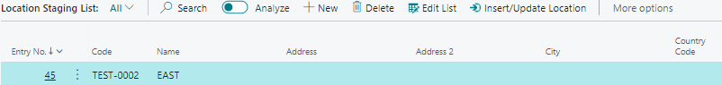

Fields
- Entry No. : This field will automatically display number, but we can also assign manually.
- Code : This field represent location code. If we get two or more records with same code from tube stream then the last record which we or job queue insert in Location will overwrite previous ones. This field is required to insert in ‘Location Master’.
- Entry Date and Time : This field will automatically display date and time when record is inserted in this staging table.
- Integration Status : This field specifies whether a record is inserted or not or if there is error while inserting. So, the status ‘Pending’ represents record is not inserted, ‘Processed’ represents record is inserted/updated and ‘Error’ represents record couldn’t inserted.
- Error Remarks : It will tell what the error is.

Action
- Insert/Update Customer : We can manually insert in ‘Location’ in Business Central with this action. When we click on this action it check for required fields like here field ‘No.’ Then if there is no error it will insert it in Location.
And ‘Integration Status’ will change to ‘Processed’. 
But if there is an error then it will change to ‘Error’ and ‘Error Remarks’ will tell what the error is. For example –
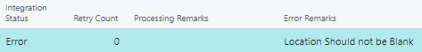
With this action we can manually insert in ‘Location’, but system will automatically insert with job queue. Job queue will run every day and it will check if there is any record with ‘Pending’ Status. If there is then job queue will insert and update it.

Purchase Order Staging
In case of Purchase Order, it will flow from Business central to tube stream.
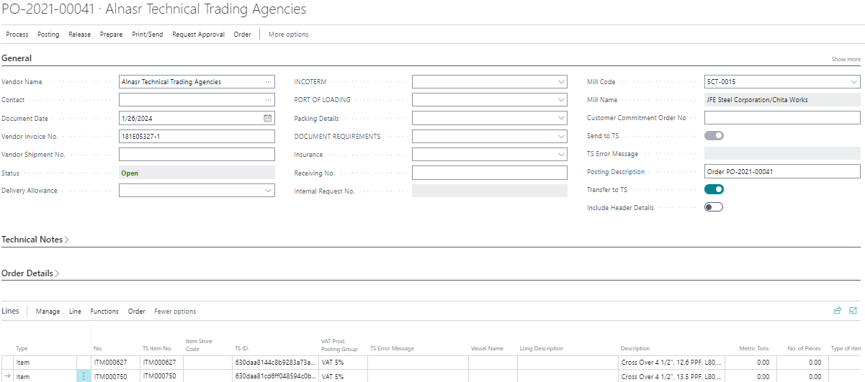
When we release purchase order it will create lines in staging table, but it will only create when we enable field ‘Transfer to TS’.
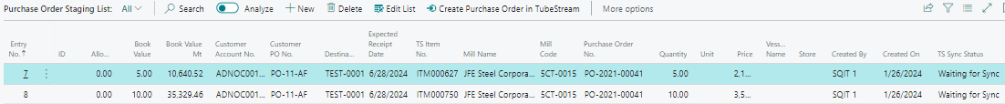

Fields
- Entry No. : This field will automatically display number, but we can also assign manually.
- Created By : User who released purchase order.
- Created On : Date when purchase order released.
- TS Sync Status : This field specifies whether a record is synced or not or if there is error while syncing. So, the status ‘Waiting for Sync’ represents record is not Synced, ‘Sync Complete’ represents record is Synced and ‘Error’ represents record couldn’t synced.
- TS Error Message: It will tell what the error is.
- TS Synced On : Date when it sync to tube stream.

Action
- Create Purchase Order in Tube Stream : We can manually Sync to Tube Stream with this action. ‘Integration Status’ will change to ‘Sync Complete’ when we click on this action if there is no error, but if there is an error then it will change to ‘Error’ and ‘Error Remarks’ will tell what the error is.
With this action we can manually Sync, but system will automatically sync with job queue. Job queue will run every day and it will check if there is any record with ‘Waiting for Sync’ Status. If there is then job queue will sync it.

Purchase Receipt Staging

Fields
- Entry No. : This field will automatically display number, but we can also assign manually.
- Purchase Order No. : Specify the purchase order no. of which we received goods.
- Purchase Receipt No.
- TS Item No. : Which item we have received.
- Entry Date and Time : This field will automatically display date and time when record is inserted in this staging table.
- Integration Status : This field specifies whether a record is inserted or not or if there is error while inserting. So, the status ‘Pending’ represents record is not inserted, ‘Processed’ represents record is inserted/updated and ‘Error’ represents record couldn’t inserted.
- Error Remarks : It will tell what the error is.

Action
- Update Purchase Receipts : We can manually insert in ‘Posted Purchase Receipts’ in Business Central with this action. When we click on this action it will insert in Posted Purchase Receipts and it will change Quantity Received in Purchase Order and it will post the Purchase Order.
‘Integration Status’ will change to ‘Processed’.

With this action we can manually insert in ‘Posted Purchase Receipts’, but system will automatically insert with job queue. Job queue will run every day and it will check if there is any record with ‘Pending’ Status. If there is then job queue will insert/update it.

Sales Order Staging

Fields
- Entry No. : This field will automatically display number, but we can also assign manually.
- Document No. : Specifies Sales Order No. If there are more than one record with same document no. then it will combine all into single sales order. This field is required.
- Customer No. : This field value must match to customer master table. This field is required.
- Quantity : This field is required.
- Location Code : This field value must match to location master table. This field is required.
- TS Item No. : This field value must match to item master table. This field is required.
- Entry Date and Time : This field will automatically display date and time when record is inserted in this staging table.
- Integration Status : This field specifies whether a record is inserted or not or if there is error while inserting. So, the status ‘Pending’ represents record is not inserted, ‘Processed’ represents record is inserted/updated and ‘Error’ represents record couldn’t create.
- Error Remarks : It will tell what the error is.

Action
- Create Sales Order : We can manually create & insert in ‘Sales Order’ in Business Central with this action. When we click on this action it check for required fields like here field ‘Customer No.’, ‘Quantity’, ‘Location Code’, etc. Then if there is no error it will create & insert it in Sales Order and a message will pop up in image below.
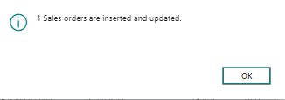
And ‘Integration Status’ will change to ‘Processed’. 
But if there is an error then it will change to ‘Error’ and ‘Error Remarks’ will tell what the error is. For example –
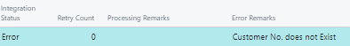
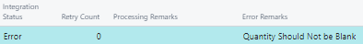
With this action we can manually insert in ‘Sales Order’, but system will automatically create with job queue. Job queue will run every day and it will check if there is any record with ‘Pending’ Status. If there is then job queue will create & insert it.

Sales Shipment Staging

Fields
- Entry No. : This field will automatically display number, but we can also assign manually.
- Sales Order No. : Specify the purchase order no. of which we received goods.
- Shipment No. : Specifies Posted Sales Shipment No.
- Entry Date and Time : This field will automatically display date and time when record is inserted in this staging table.
- Integration Status : This field specifies whether a record is inserted or not or if there is error while inserting. So, the status ‘Pending’ represents record is not inserted, ‘Processed’ represents record is inserted/updated and ‘Error’ represents record couldn’t inserted.
- Error Remarks : It will tell what the error is.

Action
- Update Sales Shipments : We can manually insert in ‘Posted Sales Shipments’ in Business Central with this action. When we click on this action it will insert in Posted Sales Shipments and it will post the Sales Order.
‘Integration Status’ will change to ‘Processed’.

With this action we can manually insert in ‘Posted Sales Shipments’, but system will automatically insert with job queue. Job queue will run every day and it will check if there is any record with ‘Pending’ Status. If there is then job queue will insert/update it.

Transfer Order Staging

Fields
- Entry No. : This field will automatically display number, but we can also assign manually.
- Transfer Order No. : Specifies Transfer Order No. If there are more than one record with same document no. then it will combine all into single transfer order. This field is required.
- From Location Code : This field value must match to location master table. This field is required.
- To Location Code : This field value must match to location master table. This field is required.
- TS item No. : This field value must match to Item master table. This field is required.
- Quantity : This field is required.
- Quantity Shipped : This field is required.
- Quantity Received : This field is required.
- Entry Date and Time : This field will automatically display date and time when record is inserted in this staging table.
- Integration Status : This field specifies whether a record is inserted or not or if there is error while inserting. So, the status ‘Pending’ represents record is not inserted, ‘Processed’ represents record is inserted/updated and ‘Error’ represents record couldn’t create.
- Error Remarks : It will tell what the error is.

Action
- Create Transfer Order : We can manually insert in ‘Transfer Order’ in Business Central with this action. When we click on this action it check for required fields like here ‘TS Item No.’, ‘Quantity’, ‘Location Code’, etc. Then if there is no error it will create & insert it in Transfer Order and a message will pop up in image below.
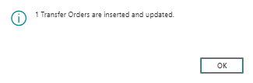
And ‘Integration Status’ will change to ‘Processed’. 
But if there is an error then it will change to ‘Error’ and ‘Error Remarks’ will tell what the error is. For example –
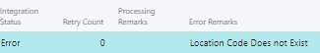
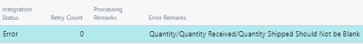
With this action we can manually insert in ‘Transfer Order’, but system will automatically create with job queue. Job queue will run every day and it will check if there is any record with ‘Pending’ Status. If there is then job queue will create & insert it.

Mill Master Staging

Fields
- Entry No. : This field will automatically display number, but we can also assign manually.
- Code : This field represent mill master code. If we get two or more records with same code from tube stream then the last record which we or job queue insert in Item will overwrite previous ones. This field is required to insert in ‘Mill Master’.
- Entry Date and Time : This field will automatically display date and time when record is inserted in this staging table.
- Integration Status : This field specifies whether a record is inserted or not or if there is error while inserting. So, the status ‘Pending’ represents record is not inserted, ‘Processed’ represents record is inserted/updated and ‘Error’ represents record couldn’t inserted.
- Error Remarks : It will tell what the error is.

Action
- Insert/Update Mill Master : We can manually insert in ‘Mill Master’ in Business Central with this action. When we click on this action it check for required fields like here ‘Code’. Then if there is no error it will insert it in Mill Master and a message will pop up in image below.
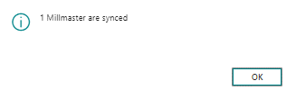
And ‘Integration Status’ will change to ‘Processed’. 
But if there is an error then it will change to ‘Error’ and ‘Error Remarks’ will tell what the error is. For example –
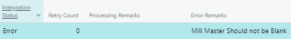
With this action we can manually insert in ‘Mill Master’, but system will automatically insert with job queue. Job queue will run every day and it will check if there is any record with ‘Pending’ Status. If there is then job queue will insert/update it.

Production Issue Receipt Stagging

Fields
- Entry No. : This field will automatically display number, but we can also assign manually.
- Document No.
- Location Code : This field value must match to Item master table. This field is required.
- Entry Type : Specifies whether it will be Negative or Positive Adjustment.
- TS Item No. : This field value must match to Item master table. This field is required.
- Quantity : This field is required.
- Entry Date and Time : This field will automatically display date and time when record is inserted in this staging table.
- Integration Status : This field specifies whether a record is inserted or not or if there is error while inserting. So, the status ‘Pending’ represents record is not inserted, ‘Processed’ represents record is inserted/updated and ‘Error’ represents record couldn’t inserted.
- Error Remarks : It will tell what the error is.

Action
- Create Production Receipts and Issue : This action create ‘Item Journal’ with Positive and Negative Adjustment. When we click on this action it check for required fields like here ‘TS Item No.’, ‘Quantity’, ‘Location Code’, etc. Then if there is no error it will create in Item Journal and a message will pop up in image below.
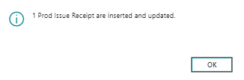
And you can see in image below of Item Journal.
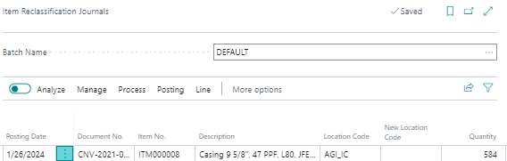
And ‘Integration Status’ will change to ‘Processed’. 
But if there is an error then it will change to ‘Error’ and ‘Error Remarks’ will tell what the error is. For example –
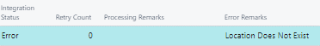

With this action we can manually insert in ‘Item Journal’, but system will automatically insert with job queue. Job queue will run every day and it will check if there is any record with ‘Pending’ Status. If there is then job queue will create/insert it.

Inventory Adjustment Staging

Fields
- Entry No. : This field will automatically display number, but we can also assign manually.
- Document No.
- Location Code : This field value must match to Item master table. This field is required.
- Entry Type : Specifies whether it will be Negative or Positive Adjustment.
- TS Item No. : This field value must match to Item master table. This field is required.
- Quantity : This field is required.
- Entry Date and Time : This field will automatically display date and time when record is inserted in this staging table.
- Integration Status : This field specifies whether a record is inserted or not or if there is error while inserting. So, the status ‘Pending’ represents record is not inserted, ‘Processed’ represents record is inserted/updated and ‘Error’ represents record couldn’t inserted.
- Error Remarks : It will tell what the error is.

Action
- Create Inventory Adjustment : This action create ‘Item Journal’ with Positive and Negative Adjustment. When we click on this action it check for required fields like here ‘TS Item No.’, ‘Quantity’, ‘Location Code’, etc. Then if there is no error it will create in Item Journal and a message will pop up in image below.
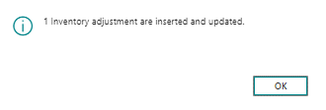
And you can see in image below of Item Journal.
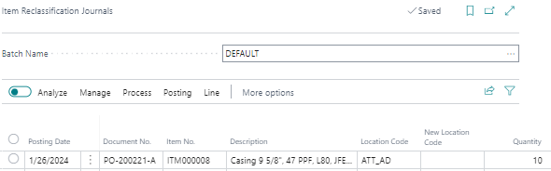
And ‘Integration Status’ will change to ‘Processed’. 
But if there is an error then it will change to ‘Error’ and ‘Error Remarks’ will tell what the error is. For example –

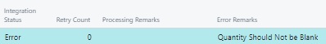

With this action we can manually insert in ‘Item Journal’, but system will automatically insert with job queue. Job queue will run every day and it will check if there is any record with ‘Pending’ Status. If there is then job queue will create/insert it.

Vendor Staging
In case of Vendor, it will flow from Business central to tube stream.
When we create a vendor in Business Central, it will automatically get created/updated in vendor staging table.

Fields
- Entry No. : This field will automatically display number, but we can also assign manually.
- Code
- Created By : User who created Vendor.
- Created On : Date when vendor was created.
- TS Sync Status : This field specifies whether a record is synced or not or if there is error while syncing. So, the status ‘Waiting for Sync’ represents record is not Synced, ‘Sync Complete’ represents record is Synced and ‘Error’ represents record couldn’t synced.
- TS Error Message : It will tell what the error is.
- TS Synced On : Date when it sync to tube stream.

Action
- Create Vendor in Tube Stream: This action will update Vendor in tube stream.
With this action we can manually Sync, but system will automatically sync with job queue. Job queue will run every day and it will check if there is any record with ‘Waiting for Sync’ Status. If there is then job queue will sync it.

Sales Invoice Staging
In case of Sales Invoice, it will flow from Business central to tube stream.
When we post sales invoice it will automatically gets updated here in sales invoice staging.

Fields
- Entry No. : This field will automatically display number, but we can also assign manually.
- Created By : User who created Vendor.
- Created On : Date when vendor was created.
- TS Sync Status : This field specifies whether a record is synced or not or if there is error while syncing. So, the status ‘Waiting for Sync’ represents record is not Synced, ‘Sync Complete’ represents record is Synced and ‘Error’ represents record couldn’t synced.
- TS Error Message : It will tell what the error is.
- TS Synced On : Date when it sync to tube stream

Action
- Update Sales Invoice in Tube Stream: This action will update sales invoice in tube stream.
With this action we can manually Sync, but system will automatically sync with job queue. Job queue will run every day and it will check if there is any record with ‘Waiting for Sync’ Status. If there is then job queue will sync it.

Sales Return Order Staging

Fields
- Entry No. : This field will automatically display number, but we can also assign manually.
- Customer Code : This field value must match to Customer master table. This field is required.
- Item Numbers : This field value must match to Item master table. This field is required.
- Quantity Good : This field is required.
- Quantity Damaged : This field is required.
- Entry Date and Time : This field will automatically display date and time when record is inserted in this staging table.
- Integration Status : This field specifies whether a record is inserted or not or if there is error while inserting. So, the status ‘Pending’ represents record is not inserted, ‘Processed’ represents record is inserted/updated and ‘Error’ represents record couldn’t inserted.
- Error Remarks : It will tell what the error is.

Action
- Create Sales Return Orders : We can manually create & insert in ‘Sales Return Order’ in Business Central with this action. When we click on this action it check for required fields like here field ‘Customer No.’, ‘Quantity’, ‘Location Code’, etc. Then if there is no error it will create & insert it in Sales Return Order and a message will pop up in image below.
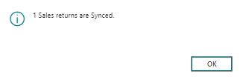
And ‘Integration Status’ will change to ‘Processed’. 
But if there is an error then it will change to ‘Error’ and ‘Error Remarks’ will tell what the error is. For example –

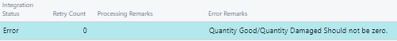
With this action we can manually insert in ‘Sales Return Order’, but system will automatically create with job queue. Job queue will run every day and it will check if there is any record with ‘Pending’ Status. If there is then job queue will create & insert it.

